**Homework #4**

**Discrete Mathematics- 2nd Semester 2018**

***Due:*** **Wednesday Dec. 19, 2018, 03:00 PM**

※Solve the following problems.

**#1. Solve the Problem #1 at Exercises 11.2**

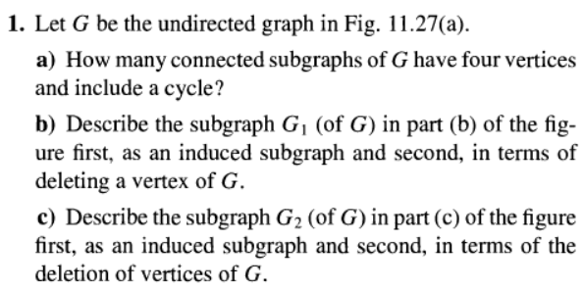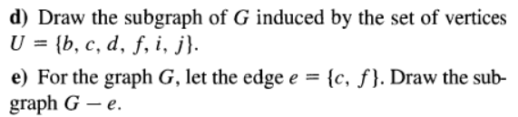

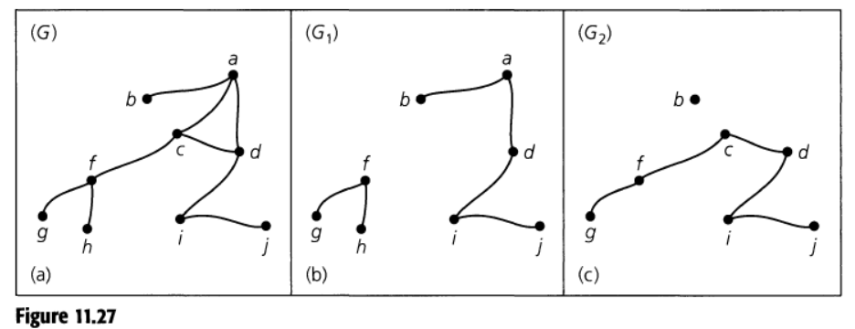

**#2. Prove the following Corollary 11.1**

EMB000019c80c7b

**#3. Prove the following Theorem 11.4**



**#4. Solve the problem (#1) at Exercises 11.3**

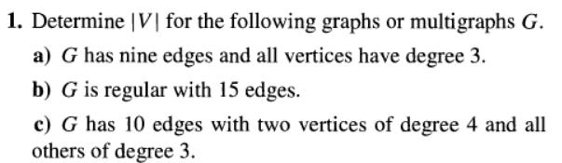

**#5. Solve the problem (#8 & #9) at Exercises 11.3**

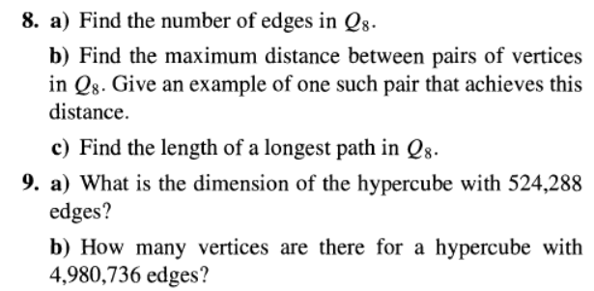

**#6. Solve the problem (#23) at Exercises 11.3**

\

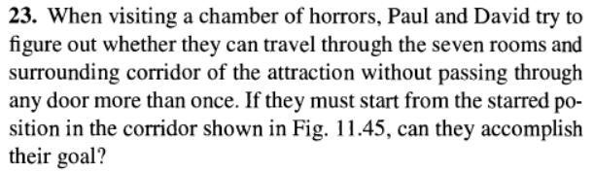

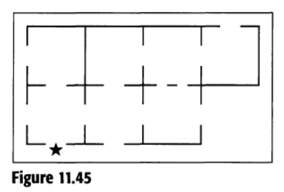

**#7. Solve the following problems. problem 9 in Exercises 11.6 (page 571)**

1. **Determine the chromatic polynomials for the graph in the following figure.**
2. **Find** EMB000019c80c82**for each graph.**
3. **If five colors are available, in how many ways can the vertices of each graph be properly colored ?**

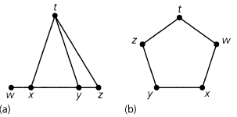

- Thanks